INTERMEDIATE MEASURES FOR SAFETY
by
G. L. McDonald M.E., B.Sc.

QUANTITY OF DAMAGE
Before discussing Intermediate Measures of Safety, it is necessary to consider the overall measures of safety – or more accurately the measures of damage to people from work in Australia. There have been only two. The Industry Commission (1995), part of Commonwealth Treasury, quantified personal damage by Cost for the year 1992-93; and the National Occupational & Safety & Health Commission (NOHSC) for the year 2000-01, adding a cost estimate of the quantity of pain, suffering and early death.

People at work are damaged by an energy exchange which goes outside tolerable limits and damages tissue and/or function. The damaged tissue and function, in turn damage the person’s life permanently (Class I), temporarily (Class II) or insignificantly (Class III). Class I includes Fatal and Non-fatal which subdivides into ‘no return to work’ and ‘return to lesser work income’. Class II is lost time injuries from which the person fully recovers and returns to full work in less than six months. Class III involves both medical treatment only and first aid treatment.

Three images from 2000-01 should become imprinted on your brain so that you know the overall problem.

Image 1 shows that Class I damage accounts for 96.5% (Fatal 6.5% and Non-fatal 90%) and Class II 3.5% of the $82.3 billion quantity of damage incurred in 2000-01 when our total exports were valued at $132 billion. Class III did not rate.

Image 2 shows that Employers carry 10.3% of the damage in their whole of life loss. Community carries 13% and Employees 76.7%. This includes the cost of pain, suffering and early death.

Image 3 shows that 7 people a day or 2500 people a year die as a result of having worked and Class I Non-fatal (permanent alteration of life) occurs to 135 each day i.e. 50,000 per year

Image 1. Quantity of Work Personal Damage in Class I, Class II and Class III.
(2000-01)
Percentage of

$82.3 billion
Exports $132 billion

Image 2. Share of Costs
Image 3. Number of Persons

 | Per Day | Day x 365 = Annual
Class I Fatal | 7 | 2500
Class I Non-fatal | 135 | 50,000

FREQUENCY RATE MEASURES
The most widely and powerfully used measures of safety performance have been Lost Time, Medical Treatment and Work Injury Frequency Rates, LTIFR, MTIFR and WIFR. Work Injury includes Lost Time, Medical Treatment and First Aid Treatment. The Rate is per million person hours worked.

Number is the dominant measure. An average time lost measure is also sometimes used, but counts only work’s loss and gives a maximum of 220 days (1 year) including for death or ventilated quadriplegic.

The Industry Commission’s quantity of damage for 1992-93 can be integrated into Class II and Class III framework as set out in Table 1.

Table 1. 1992-93 Quantity of Damage.
Distribution of Cost of Work Personal Damage

Personal Damage | $ billion
Class I Fatal | 0.299
Class I Non-fatal (no return to work) | 11.664
Class I Non-fatal (reduced work, time, skill) | 4.555
Class II | 3.614
Total | 20.00

New South Wales WorkCover Statistics from 1991-92 to 2000-01 were plotted, Lines of Regression drawn and 10 year Change Rate calculated for All Occurrences, Traumatic Fatalities, Temporary <6 Months, Temporary 6 Months+ (Class I Non-fatal –reduced work, time, skill) and Permanent (Class I Non-fatal – no return to work). These 10 year Change Rates can be used in conjunction with Table 1 to show the quantity of damage after 10 years at the Change Rates calculated above. This is shown in Table 2.

Table 2. Cost of Work Personal Damage in Australia

 | 1992-93 cost  $ billion | % Change | Cost 10 years on  $ billion
Class I Fatal | 0.299 | - 26.1 | 0.22
Class I Non-fatal upper | 11.664 | +140 | 27.99
Class I Non-fatal lower | 4.555 | + 61 | 7.33
Class II | 3.614 | - 36 | 2.31
Total | 20.00 |  | 37.85

89% higher

If the cost of pain, suffering and early death were included the increase in the quantity of damage would be more like 180%.
Throughout this 10 year time period, the All Injury Incidence fell by 13.4%.

Incidence (occurrences per 1000 wage and salary earners) closely approximates LTIFR (occurrences per million hours worked) to the extent that the change in LTIFR would be similar to the 13.4% reduction.

Using Incidence (LTIFR) as a measure, the 1992-93 $20 billion should become 13.4% less i.e. $17.3 billion after 10 years; whereas the NSW data used by severity gives $37.85 billion (ignoring pain, suffering and early death).

In short, the LTIFR is an invalid measure since it does not measure what it purports to measure – safety performance. It should therefore not be used. While the LTIFR’s reliability ceases to be a consideration, it is not necessary to discuss the 10 different ways of ‘massaging’ the figures i.e. falsifying. Even if the LTIFR were a valid measure, it would be disqualified from use because of its low reliability.

CLASS I RARITY
Intermediate measures are necessary because Class I cases are relatively rare. On NOHSC (2004) figures:

Table 3. Person years per occurrence for each severity class

Severity |  | Person Years per Case
Class I | Fatal - traumatic | 23000
 | - disease | 4300
Class I | Fatal – total | 3600
Class I | Non-fatal – upper | 350
 | Non-fatal – lower | 430
Class I | Non-fatal – total | 200
Class II |  | 32
Class III |  | <30

Class II measures have been shown to be invalid predictors of Quantity of Damage which is 96.5% Class I. Class I cases are too rare for them to be a measure. Sufficient must be known about them to measure the potential for their occurrence. Step back, learn from our past of depending on the LTIFR – an invalid and unreliable measure, and commence the quest for valid reliable measures. Any measures whose validity has been established by comparison to or correlation with the LTIFR must also be assumed to be invalid.

Gould (1996 p181) in ‘The Mismeasure of Man’ charts the wretched history of attempts to measure intelligence. He argues strongly against the fallacy of reification – the conversion of abstract concepts into entities (things). The French psychologist, Binet, who developed tests to identify those children whose lack of success in normal classrooms suggested the need for some form of special education expressed the view ‘the scale, properly speaking, does not permit the measure of the intelligence, because intellectual qualities are not superposable, and therefore cannot be measured as linear surfaces are measured’ (1905, p40.) Reading this book led to the conclusion that there is no such ‘thing’ as safety. More accurately safety is not a thing. It is an abstract mental concept meaning ‘free from the potential of damage.’

The problem of reification is that it leads to inappropriate behaviour to the non-existent thing, and to behaviour which is similarly inappropriate to the component parts which have been artificially cobbled together by the reification. Safety is a perfectly legitimate word but it is not a thing. Using frequency rate measures in attempting to quantify it was inappropriate from the start. Read Gould to understand the enormous injustice from reifying intelligence. Similarly, injustice has come from use of the Lost Time Injury Frequency Rate.

SAFE FROM
People at work are damaged by energy e.g. Gravitational, Human, Machine (Vehicular), Chemical, Electrical, Emotional and many others. In Brisbane, I am safe from starving to death and safe from freezing, The safety objective must be to make people ‘Safe From’ Class I damage from the various energy types. While it is necessary to make people safe from Class I damage from all the potential damaging energies, it is wise to start where the maximum gain can be achieved.

Table 4. Human and Gravitational Energy contribution to Class I Non-fatal-upper personal damage.

Mechanism of Injury | Number of cases | % of cases
Manual handling | 12412 | 35.4
Bending, stretching, reaching | 2503 | 7.1
Hitting stationary objects | 1226 | 3.5
Total Human Energy | 16141 | 46.0
Falls to same level | 4810 | 13.7
Falls from height | 3684 | 10.5
Falls of objects | 1462 | 4.2
Total Gravitational Energy | 9956 | 28.4

Human and Gravitational Energy combined account for 74.4% of Permanent Disability (Class I Non-fatal – upper)

New South Wales has the largest workforce in Australia and WorkCover has produced data on Permanent Disability and Temporary Disability, 6 months and over (Class I Non-fatal, upper and lower). To illustrate the approach Class I Non-fatal upper figures have been aggregated over four years 1996-97 to 2000-01 to give 35048 cases. As seen in Table 4 above, Human Energy and Gravitational Energy are the dominant energies for this severity level which from NOHSC (2004) costing for 2000-01 account for $53.1 billion (64%) of the $82.8 billion quantity of damage to the Australian workforce.

Assume we work for the NSW Government. What measuring system could we develop and give to industry, large and small, so that they could measure improvement in making people at work Safe From Human Energy and Safe From Gravitational Energy.

When it comes to a specific industry, the major damaging energy may be different. A study by McDonald, E.L. (1996) showed that ‘Vehicular energy – Ride Disturbance’ was responsible for 27% of occurrences and 49% of costs for cases more severe than 90 days off work and including fatalities in the New south Wales and Queensland Open Cut Coal Industry. Only ‘Vehicle (Plant) Operators’ (trucks, loaders, graders, bull dozers etc) were exposed to this damage.

The first step is to identify what the organization needs to make its people ‘safe from’ i.e. safe from Class I damage. This requires that a prediction of the most likely (energy type) ways in which a person will receive Class I damage be made, and the quality of that prediction measured. The better the prediction, the more on target control activities will be.

CONTROL ACTIVITIES
While the Hierarchy of Controls is technically sound and has been widely accepted, evidence of its effective use is less impressive.

The Hierarchy

- Elimination (get rid of the potential damaging energy)
- Substitution (replace with an energy of much lower potential)
- Engineering (prevent mechanism of release of energy or impingement of energy on a person)
- Administration (organize procedures, work systems, personal behaviour etc)
5. Personal Protection Equipment (supply and ensure the wearing and use of PPE)

requires that 4 and 5 only be used when 1, 2 or 3 is not possible. In general, the control by items from 1, 2 and 3 will be reliable for the life of the operation, while those from 4 or 5 are fallible and will require constant effort to keep them functioning effectively.

The damaging energy exchange occurs as a result of or during a task activity. Only when the task activity has been changed so that the potential for Class I damage has been reduced is the extent to which the person is safe from improved.

To achieve change there needs to be a process which results in prediction and control action. Typical processes involve use of standard operating procedures, job safety analyses, risk assessments, behaviour observations, safety committees, inspections and the like. Within these processes, there will be some level of content i.e. veridical (true saying) knowledge of the phenomena involved in damaging people and of what changes in the task activity will reduce the potential for Class I damage and to what extent. There must also be changes in the task activity. Until the changes in the task activity occur, there is no reduction in the potential for damage. There are then four levels which can be measured.
- Prediction
- Process
- Content
- Change in task activity

METHODS USED
There is a wide range of methods currently in use. At one extreme, all four levels are coalesced into one where the front line worker, based on his or her own experience and acceptance of responsibility predicts (identifies hazard), uses a process (risk assessment) whose content is the person’s experience and changes the task activity (usually from (4) or (5) of the Hierarchy). At the other extreme, Taxonomies (see Figure 1) are used to facilitate harvesting of workforce experience, which combines with knowledge from the scientific literature of the phenomena involved, to guide observation and identify potentials. All levels of the workforce take part and increase their knowledge as does everyone involved.

The only direct intermediate measures of the improvement in Safe From are the quality of prediction of the potential sources of Class I damage and the quality of the control measures which alter the task activity. The activity may have been eliminated, or grossly altered by modification of equipment involved. Energy and Ergonomic controls are required. The process itself does nothing if the content does not exist. Similarly, ‘content’ without process has no way of being delivered. Measures of process and of content can be used to help improve each. Such measures, however, should not be seen conceptually as an intermediate measure of ‘safe from’. Improvement only comes when task activities are modified, and particularly modified by Elimination, Substitution or Engineering.

PREDICTION OF POTENTIAL FOR CLASS I DAMAGE
The first desirable step in Class I prediction is the experience history, preferably in Taxonomic form. Table 4 showed ‘Falls from Height’ accounted for 10.5% of Class I Non-fatal –upper (permanent disability – no return to work) - $5.5 billion per year. Figure 1 is a Taxonomy of 791 litigated Class I falls involving a change of height. Note the high involvement of slips and of stairs (188), mobile machinery (102) and ladders 45 + 35. Which from the Taxonomy are relevant to you?

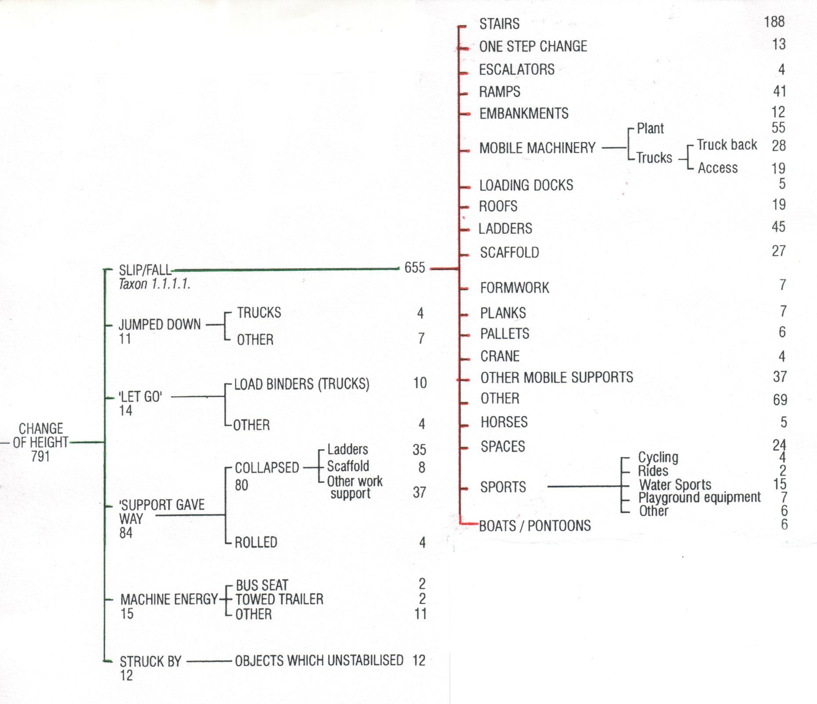
Figure 1. Section of a Taxonomy showing ‘Change of Height’

The same study showed ‘Falls to the same level’ were 360 slip to 70 trip. Note Table 4 shows ‘Same level’ 13.7% and ‘From Height’ 10.5%. Human energy is dominantly ‘Manual Handling’ – lifting, pushing, pulling 35.4%.

Accuracy in predicting potential is critical and cannot be done from your own experience. You need the experience of others. Armed with Class I predictive insight, maximize the use of your own (organisation’s) experience by interviewing members of the workforce whose incipient slip experience or exertion or effort or near-miss experience can identify places or task activities with Class I potential.

CHOICE OF ACTION
Control action must be based on a veridical knowledge of what change will be effective. This large topic is beyond the scope of a single paper, but some pointers help. In falls, the type of injury is not critical as the control is predominantly to stop slipping (better grip between heels (level) and soles (height) on contaminated surfaces. Geometry, uniformity, nosing grip and black/white visual definition is critical in steps and other height (machinery access) cases.

With ‘Manual handling’, the injuries must be known as they come from different mechanisms. The most common come as a result of the muscular contraction and resulting force used to deal with external loads. Overloading (bending moment), sustained loading and operating with a joint well away from its normal alignment, under load, continuously or repeatedly are strongly involved as a generality. All need reducing. The most popular ‘control measure’ used for reducing back damage – correct lifting technique, keep your back straight and lift with your legs, not only would not get a positive mark, but should be given a negative mark as it delays the introduction of effective control techniques – reducing the bending moment on the lumbar spine.

THE UNDERLYING THEME
Underlying this paper is the theme that reduction in Class I potential is best achieved by Energy Management rather than by the longstanding preoccupation with human behaviour and, in particular, with human error i.e. ‘doing it better.’ In many cases the term ‘human error is technically incorrect and applied to a spandrel i.e. a by-product of the evolutionarily developed brain functions, which generally serves us well. A spandrel, an inherent feature of a human’s operating characteristics, is only seen as an ‘error’ when it is fitted into a system or way of working which does not allow for it. The use of the concept ‘human error’ has been essential to many deaths and permanent disabilities by inhibiting the introduction of effective control measures e.g. Residual Current Devices and Roll Over Protective Structures.

William Haddon was one of the first to introduce the concept of injury being the result of an energy exchange in 1963. It is worth paying attention to his Energy Management Strategies to help guide selection of controls and for measuring efficacy of controls.

- Prevent the initial marshalling of energy.
- Reduce the amount of energy marshalled.
- Prevent the release of energy.
- Modify the rate or spatial distribution of release of energy from its source.
- Separate (in space and time) the energy being released from the susceptible parts.
- Separate the energy being released from the susceptible parts by interposing a material barrier.
- Modify the contact surface, subsurface or structure which can be impacted.
- Strengthen the living or non-living part which might be damaged by the energy transfer.
- Move rapidly in detection and evaluation of damage to counter its continuation and extension.

RELIEVING FRUSTRATION
By now, many will be frustrated because this paper has not given an intermediate measure nor endorsed any intermediate measure. Rather, it has said do not repeat or continue in different guise the long running counterproductive use of invalid measures e.g. LTIFR, or unreliable measures.

Make a major effort to validly predict the potential for Class I damage. Seek veridical knowledge for controls for potential damaging occurrences. Do so energy by energy. What is the potential for Class I damage from Gravitational, Human, Machine, Vehicular, Object, Chemical, Electrical etc. Where is the energy stored or utilized? How can the energy be released? How will the energy impinge on and affect a person?

Examine your safety processes and the content of those processes. Evaluate them by valid methods to improve their effectiveness.

Measure the change in task activities where these changes make people Safe From the potential of damage from one of the energies. This is the only measure which can stand up as a valid intermediate measure and it will only do so when it eliminates or reduces the potential for Class I damage. The reliability of the change should be assessed as part of the measure.

References

Gould, S. J. (1996). The Mismeasure of Man. W. W. Norton & Company Ltd, London.

Industry Commission (1995). Work, Health & Safety. Inquiry into Occupational Health & Safety. Report No. 47, Vols. 1 and 2, Industry Commission, LB2, Collins St. Melbourne, Australian Government Printing Service

McDonald, E.L. (1997). Taxonomy - Accidents in the Coal Mining Industry. Prepared for New South Wales Minerals Council and the Queensland Mining Council.

National Occupational Health and Safety Commission (2004). The Cost of Work-related Injury and Illness for Australian Employers, Workers and the Community. August 2004.

NSW WorkCover (2002). Statistical Bulletin 2000-01.

